**Shri Vaishnav Vidyapeeth Vishwavidyalaya, Indore**

**Shri Vaishnav Institute of Information Technology**

**Department of computer science and engineering**



**PROJECT**

**B. Tech + MBA**

**Subject: Advanced Java Programming**

**Enrollment no.: 1810DMBCSE03313**

**Course Code: BTCS-409**

**2nd Year /4th semester**

**Submitted by Subject Teacher**

**Sanskar Bomb Mr. Sachin Chirgaiya**

**Objective:**

**A Banking system** software where manager can add/view/delete account, can deposit or withdraw money and can print record.

**Users of the System**

1. Manager

**Functional Requirements**

**1. Manager**

1. Can add/view/edit/delete account
2. Can logout

**Tools used**

1. Use any IDE to develop the project. It may be Eclipse /MyEclipse / NetBeans etc.
2. File system.

**ACTIVITY DIAGRAM:**

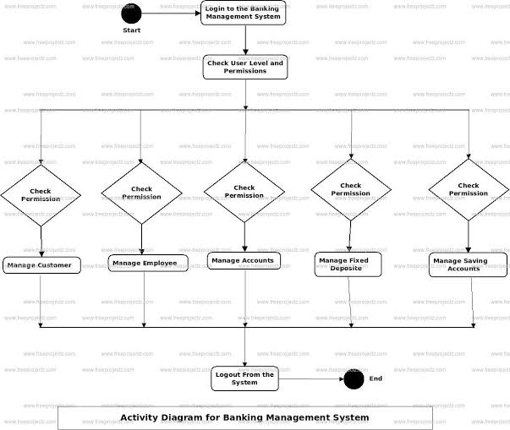

**CLASS DIAGRAM:**

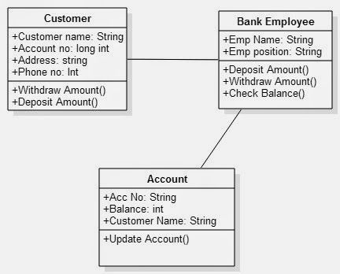

**DATA FLOW DIAGRAM:**

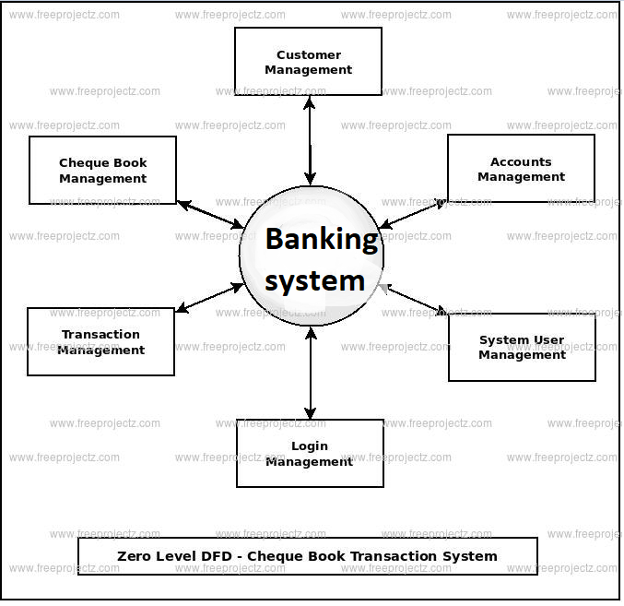

**Sequential diagram:**

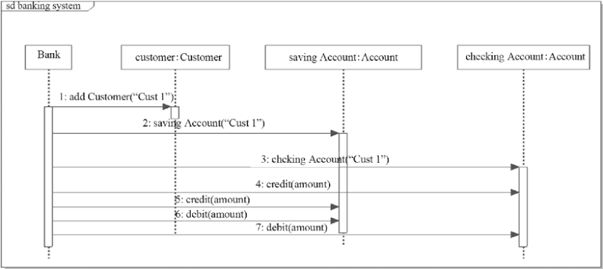

**ER- Diagram:**

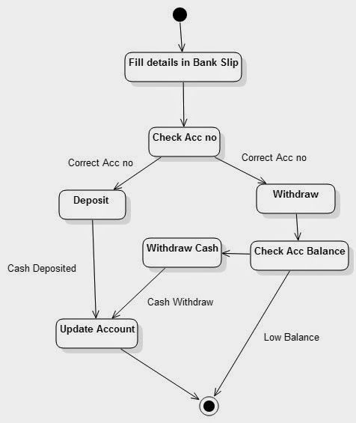

**How project works?**

**Screenshots of output:**

**Create an account**: Enter account number as well as details of account holder

Then click on save button.

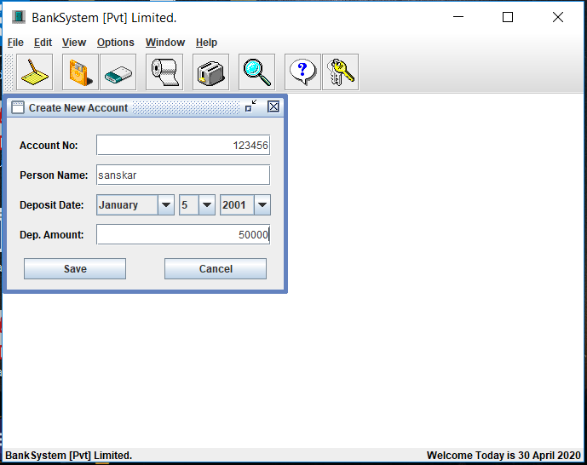

**View accounts**: here manager can see record of all accounts.

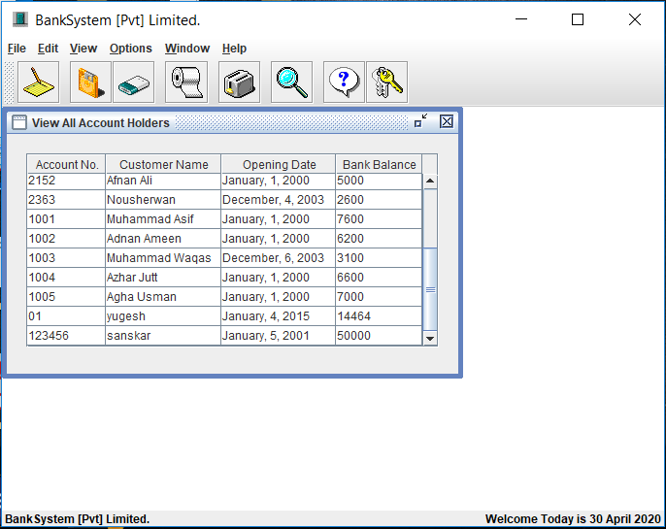

**Deposit:** manager can deposit money in account.

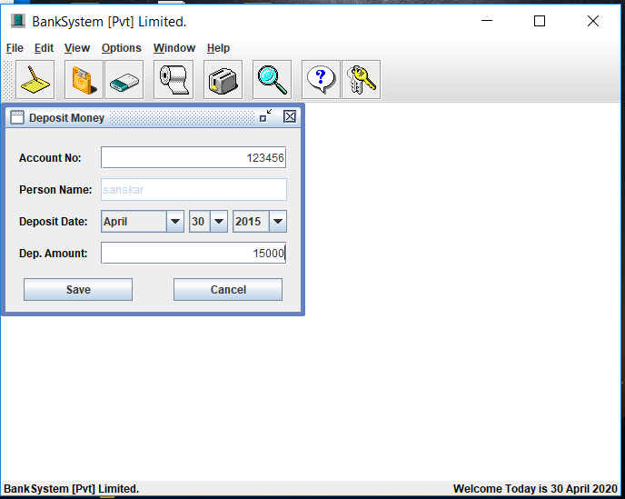

**Withdraw:**  Manager can withdraw money from given accounts.

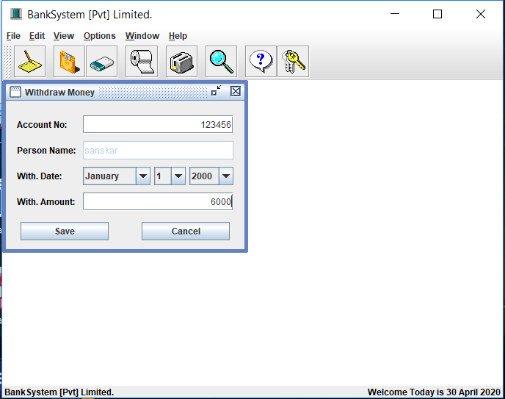

**Print**: Here manager can print the customer balance.

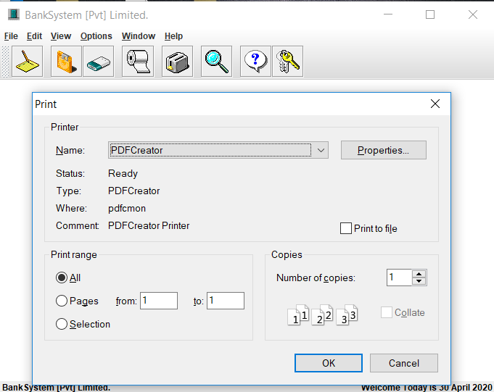

**Delete customer:** Here manager can delete accounts.

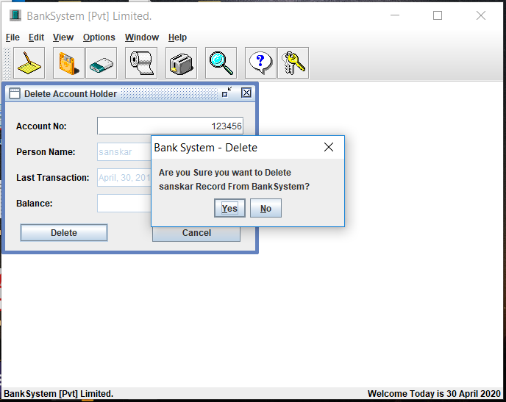

**Logout:** through this button manager can logout from the system.

